  - 2026
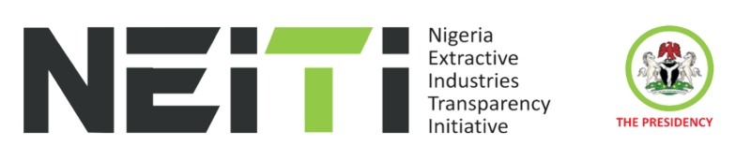
COUNTRY WORK PLAN

WORK PLAN NARRATIVE
ACRONYMS AND ABBREVIATIONS

Acronym Meaning

CSSC Civil Society Steering Committee
EITI Extractive Industries Transparency Initiative
ETP Energy Transition Plan
FAAC Federation Account Allocation Committee
FASD Fiscal Allocation and Statutory Disbursement Audit
FGN Federal Government of Nigeria
GAAP Generally Accepted Accounting Principles
IMTT Inter-Ministerial Task Team
IPSAS International Public Sector Accounting Standards
NEITI Nigeria Extractive Industries Transparency Initiative
PME Planning, Monitoring and Evaluation

Table of Contents

Introduction 3
Nigeria EITI 2024 Country Work Plan 4
Country Work Plan Objectives:……….........................................................................................4
Country Work Plan Assumptions: 5
Work Plan National Priorities 5
Work Plan international Priorities…………………………………………………….……………………………………………….5
Methodology……………………………………………………………………………………………………………………………………..5
Funding……………………………………………………………………………………………………………………………………..………5
Summary of Funding…………………………………………………………………………………………………………………….……6

Introduction:

The Nigeria Extractive Industries Transparency Initiative (NEITI) country work plan for year 2026 is developed in compliance with requirement 1.5 of the global Extractive Industries Transparency Initiative (EITI) 2023 standard. The work plan, which is the fifth one in the series the implementation of Nigeria EITI’s 2022-2026 Strategic Plan is anchored on NEITI’s three strategic objectives, namely:

(i) To sustain extractive sector reporting and relevance by focusing on national and international priorities;
(ii) To strengthen extractive sector governance and reforms through policy research and strategic stakeholder engagement; and
(iii) To achieve operational excellence through professionalism, innovation, use of technology and resource management.

The programmes and activities in the 2026 work plan have been deliberately designed to deliver on the objectives of the strategic plan, sustain effective implementation of the EITI in Nigeria and contribute to the achievement of country’s economic priorities. The work plan, built on the previous ones, also covers new provisions of the 2023 EITI standard on anti-corruption; energy transition; domestic resource mobilization, revenue collection, gender, social and environment issues.

The total budget for the workplan is ₦3.76billion, with a funding gap of ₦160 million. The funding gap is expected to be addressed through partnerships and donor support. This work plan aims to sustain NEITI’s role in shaping governance reforms, ensure optimal benefits from Nigeria’s natural resources, and promote a fair and sustainable energy transition.

Nigeria EITI 2026 Country Workplan

The Nigeria EITI 2026 country work plan is structured to enhance the impact of the EITI implementation and maximise revenue to the Nigerian government through programmes and activities that are designed to promote transparency, accountability and reduce corruption in the management of the country’s oil, gas and mineral resources. When implemented, the plan would consolidate on the gains recorded in Nigeria’s extractive sector from implementation of previous work plans in the areas of policy reforms; public availability and accessibility of extractive industries data and information to support government revenue mobilization and recovery, strengthened demand for accountability by citizens; and improved environment for business.
The policy and stakeholders’ engagement components of the plan seeks to strengthen citizens’ participation and understanding of natural resource management through information and data disclosure to promote robust public debates and cause reforms in the sector. The plan also aligns with Nigeria’s national and international priorities to attract foreign direct investment, promote economic growth and development, and contribute to the implementation of Nigeria’s Energy Transition Plan (ETP) and support Nigerian contribution to the realization of global agenda on transition from fossil fuel to a cleaner energy sources and meet net-zero target by the year 2060.

Country Work Plan Objectives:

The specific objectives of the plan are to:

1. Broaden and deepen stakeholder engagements in the NEITI process through strategic communications
2. Increase public access and understanding of NEITI reports, policy briefs and knowledge products through effective dissemination.
3. Facilitate timely implementation of extractive industries audit recommendations through effective inter-agency collaboration.
4. Improve extractive industries governance and anticorruption initiatives through policy research and engagements.
5. Improve extractive industries reporting through regular and timely audit and disclosures.
6. Increase impacts and relevance of NEITI by focusing on national and international priorities.
7. Optimize efficiency and effectiveness in NEITI operations through effective human resource management, planning, monitoring and evaluation.

Country Work Plan Assumptions:
The work plan is anchored on the following assumptions:

- Effective Leadership
- Resources Adequacy
- Political support/stability

Supporting National Priorities:
The 2026 work plan is focused on contributing to the achievement of policy priorities of Federal Government of Nigeria. The plan will also contribute to the realization of the Renewed Hope Agenda of the current administration. The government policy priorities revolve around: consolidating macro-economic stability, promote job-creation, inclusive growth, strengthen human capital and social protection, improve business and investment environment, ensure fiscal discipline, transparency and value-for-money spending.

Supporting Plan International Priorities:
The International priorities that shaped the 2026 work plan include:

➢ Tackling Corruption
➢ Strengthening Domestic Resource Mobilization
➢ Transparent and just Energy Transition

Methodology:

The process of developing the 2026 country work plan involved information and data gathering across all departments in the NEITI’s Secretariat. The process also involved progress review of previous work plans, and corrective actions/recommendations of the Nigeria EITI Validation report 2023. Inputs were equally sought from stakeholders. This work plan was thereafter presented to the National Stakeholders Working Group (NSWG) for consideration and approval at its meeting held in December 2026.

Funding:
There are two sources of funding for the activities outlined in the work plan namely: annual budgetary allocation from the Federal Government of Nigeria (FGN), and funding support from development partners, which could be in cash or in kind. The total budget estimate to implement the plan is N3,756,096,397. Out of the figure, Federal government of Nigeria is providing N3,570,196,397 while N191,000,000 funding support is expected from development partnership. A sum of N160,000,000 is estimated as funding gap.

Summary of Funding:
Strategic Objective | Total (N) | FGN (N) | Donor (N) | Funding Gap (N)
Strengthen extractive sector governance and reforms through policy research, strategic stakeholder engagement, communication, and inter-agency collaboration | 918,246,663.53 | 727,246,663.53 | 191,000,000.00 | - 80,000,000.00
Sustain extractive sector reporting and relevance by focusing on national and international priorities | 310,538,089.26 | 310,538,089.26 | - | -
Achieve operational excellence in implementing the NEITI mandate through Professionalism, innovation, use of technology, resource management, and capacity building. | 2,527,311,645.05 | 2,527,311,645.05 | - | - 80,000,000.00
Total (N) | 3,756,096,397.84 | 3,570,196,397.84 | 191,000,000.00 | (160,000,000.00)

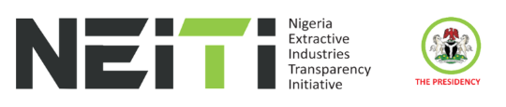

NEITI 2026 SERIES

See EITI Standard 2023: https://eiti.org/sites/default/files/2023-06/2023%20EITI%20Standard.pdf

